

IMAGE MORPHING USING PYTHON

by
Sri Kaylan Bhavanthi

PREPARED FOR
George Antoniou
CSIT697_90FA24 Master’s Project.

Table of contents

Abstract---------------------------------------------------------------------2

Introduction----------------------------------------------------------------3

Literature Review---------------------------------------------------------6

Methodology--------------------------------------------------------------11

Code------------------------------------------------------------------------17

Result-----------------------------------------------------------------------21

Conclusion-----------------------------------------------------------------24

References-----------------------------------------------------------------27

Abstract:

In particular for manufacturing, construction, and image-based medical industries that heavily depend on image analysis, morphological image processing is essential in improving accuracy and precision in the interpretation of images. Morphological procedures are largely utilized to accentuate certain details or areas of interest within an image by modifying object or area shape within the image. Through such a procedure, the image quality and usage can be greatly improved, which results in a higher degree of precise interpretation and judgment.

Feature extraction is a core component of morphological image processing because it's all about finding and isolating important characteristics from an image to study further. Traditional feature extraction algorithms such as Principal Component Analysis (PCA) and Histogram of Oriented Gradients (HOG) have been present for some time to carry out the function. That was transformed with new advancements in deep learning and neural networks, where the domain of feature extraction became much stronger and responsive through representative learning.

The five fundamental morphological image processing methods outlined in this paper include opening, closure, erosion, dilation, and the use of kernels similar to the sliding window method used by convolutional neural networks (CNNs). Utilizing the morphological operations in a systematic way on the image, the kernel-based approach enables high-level image data extraction, improving accuracy and flexibility of image analysis tasks. Through these methods, we seek to discuss how morphological image processing may be utilized to enhance picture interpretation accuracy across different businesses and industries to facilitate more accurate and effective decision-making..

Introduction:

Image Analysis: Evolution from Manual Methods to Deep Learning

Over its long and noble history, image analysis has seen a miraculous transformation. Image analysis was manually performed prior to the widespread adoption of deep learning (DL) and artificial intelligence (AI) techniques. Analysts utilized rough, manual devices like callipers, planimeters, and densitometers to measure out meaningful information from images.

Each of these tools had a specific purpose:

• Callipers calibrated linear distances among objects in a picture. They provided straightforward yet useful information concerning the size or comparative position of image features.

• Planimeters calculated irregularly shaped figures' area. The tools allowed analysts to calculate the surface area of objects where geometric formulas weren't easily utilized.

• Densitometers calculated material density in an image, often used in medical imaging or materials science to quantify tissue or material density.

These human techniques were the foundation of the first image analysis, yet accuracy and speed were frequently restricted. Perhaps the biggest limitation of these techniques was the possibility of human error. As the technique was greatly reliant on the experience and skills of the analyst, errors were frequent and yielded inconsistent results. Also, being manual techniques, they were time-consuming and tedious, taking lots of effort and resources to examine complex images or very large datasets.

Deep learning and artificial intelligence have revolutionized image analysis. Deep learning models, especially convolutional neural networks (CNNs), surmount all the shortcomings of the manual procedures, the biggest among them being the precision problem. Deep learning models are able to learn and automatically discover features from the data itself as compared to classical approaches which rely on pre-defined, human-engineered features. The fact that the models can learn from raw data means they can identify very subtle relations and patterns in the images that cannot be detected by human analysts. Therefore, deep learning is more comprehensive, precise, and enlightening compared to manual analysis. Deep learning models not only increase the precision but also offer colossal benefits in efficiency.

AI-powered automated analysis is also much faster than traditional analysis, and it is able to analyze large volumes of images within a fraction of the time taken by manual analysis. Furthermore, deep learning models' ability to learn and adapt new features automatically on a continuous basis means that the models can improve with time and become more efficient as they handle growing volumes of data

Enhancing Image Visibility with Morphological Image Processing

Morphological image processing is a general technique primarily used to improve the definition and visibility of features in an image. This ability to boost image quality finds special significance where there is intensive reliance on reliable image analysis, such as medicine and manufacturing industries, where masses of image data are handled daily.

In manufacturing, such as in producing computer components, morphological operations like erosion are indispensable. For example, as outlined in a paper by, the erosion operation is applied to separate overlapping capacitors on printed circuits. Through removal of small-scale structures and improving the image, erosion facilitates individual components being distinguishable more easily, contributing to accurate measurements as well as quality control. This is especially notable in electronics production, where precision is critical to the successful performance of the end product.

It is the same in medicine as well, as morphological processing techniques are as much of a factor there as anywhere else, particularly in using angiography to visualize blood vessels in the body. As documented by a paper by [4], dilation is used to enhance angiographic images, and the blood vessels stand out more clearly. Dilation does this by increasing the size of lighter spots on an image, making obscured or small vessels more visible. Physicians are subsequently able to more easily view and diagnose conditions such as arterial blockage or aneurysms. By making medical images clearer, dilation essentially leads to more accurate diagnosis and better care for the patient.

These examples amply demonstrate the usefulness of morphological image processing in daily life. In industry and medicine, operations like erosion and dilation have a central place in improving the accuracy and reliability of image data so that intelligent choices can be made. With evolving technology, the importance of morphological image processing can only grow, which can result in improved product quality and improved health outcomes.

Problem Definition and Goals

Background and Context

Morphological image processing is one of the most critical areas of image analysis and is widely used in image feature extraction for shape description and region description applications. In the past, this has been done using software such as MATLAB, C++, and ImageJ, with their strengths and weaknesses. But with growing requests for a more flexible, cost-effective, and scalable option—especially in research and universities—the shift toward Python has gained speed. The purpose of this study is to explain and emphasize how Python addresses simple morphological image processing problems in relation to MATLAB and C++.

MATLAB: A Matrix-Oriented Powerhouse with Licensing Constraints:

MATLAB has long been a favorite for image analysis among researchers and engineers due to its matrix-based architecture and special toolboxes. It also offers a collection of good native functions for morphological processing:
- imdilate(): Performs dilation, expanding the boundaries of foreground objects.
- imerode(): Performs erosion, shrinking the boundaries of objects.
- imopen(): Performs opening, a combination of erosion followed by dilation.

In addition, MATLAB possesses many and better scientific computing and visualization capabilities. These are particularly useful in the case of image data sets. However, in spite of all its strengths, MATLAB is also plagued with one particular blemish: it is not open source. Its expensive licensing scheme renders it less accessible, particularly in academic or budget-limited research environments.

C++: High Performance at the Cost of Development Time:

C++ brings unprecedented run-time speed and efficiency, which are perfect for any application that encompasses real-time processing of images. But with the power and the liberty of C++ comes responsibility. It neither supports morphological operations in the least. Its developers have to provide hand-coded low-level implementation for them, i.e.
- Handling pixel-by-pixel operations.
- Creating application-specific structuring units (kernels).
- Performance tuning and memory management manually.

While this delivers high performance and control, it also delivers slow, awkward, and error-prone programming, especially for researchers who are not highly proficient at low-level programming.

Python: Bridging the Gap with Simplicity and Power:

Python has emerged as a leading image-processing language since it is open-source, easy to use, and has exceedingly rich libraries. Python, unlike MATLAB, is freely available to be used, and therefore ideal for studies and research. Python gets rid of a lot of development complexity over C++ because it offers intrinsic functions and libraries that take care of a large part of low-level processing.

Key Python libraries for morphological image processing include:

- OpenCV (cv2.morphologyEx, cv2.dilate, cv2.erode)
- scikit-image (morphology.dilation, morphology.erosion, etc.)
- TensorFlow (for neural network operations)
- Pillow (for image operations)
- Numpy (For matrix operations and kernel definitions)

With Python, users would only have to specify a structuring element (kernel), and thereafter use a single function call to perform the desired morphological operation. This saves time and effort required for implementing sophisticated operations, without losing performance in most non-real-time applications.

The primary goal of this study is to:

- Discuss the usage of Python for morphological processing of images and particularly in academics and research purposes.
- Compare Python's ability with classic tools such as MATLAB and C++ regarding ease of use, flexibility, and performance.
- Show Python's powerful libraries to illustrate real-life applications of basic morphological operations (i.e., erosion, dilation, opening, closing).
- Highlight the advantages of Python's built-in support, open-source nature, and educational suitability.

Literature Review:

Image Morphology and Feature Extraction

Image morphology is a field of image processing that is concerned with the analysis and manipulation of shapes or structures of objects in an image. It is a part of image analysis by providing techniques to extract, alter, or manipulate features that define an object's description in an image. It is important in medical imaging, robotics, and computer vision, among others, where objects' structure is wanted.

Image morphology uses dilation, erosion, opening, and closing operations to transform the image and extract its significant features more effectively. It is directed towards emphasizing object shape, structure, and patterns so that analysis can be applied further in order to classify or predict the contents of the image.

One of the characteristic aspects of image morphology is feature extraction—the separation and identification of interesting features from the image. Later analysis, or as input to a machine learning system, can utilize them.

Traditional Feature Extraction Techniques

Regional Volumetric Distinction Maps

One of the traditional feature extraction techniques used in image morphology is Regional Volumetric Distinction Mapping (RVDM). It works by:

- Image division: The given image is divided into separate regions based on some criterion such as intensity, color, or texture.
- Finding spatial differences: The technique calculates the spatial differences between the regions. It helps to emphasize boundaries, transitions, and inter-relations among various image segments.
- Interpreting morphology: With these spatial changes, the approach attempts to understand the overall morphology of the image, i.e., the shape, structure, and organization of the objects within the image.

RVDM is directed primarily at region-based analysis and is therefore effective at locating and delineating the large-scale structure of an image. It may, however, be poor at detecting fine details or complex patterns within images, especially if the distinctions between regions are not very striking.

High Dimensional Rate Transformation (HDRT)

Another technique of conventional analysis is the use of High Dimensional Rate Transformation (HDRT). The procedure involves transforming the image to a high-dimensional space and then examining the spatial contrasts of the regions. The objective is to understand how every region of the image is connected to the others in terms of their morphological characteristics.

HDRT is particularly useful for:

- Capturing detailed spatial relations: By mapping the features of the image into higher dimensions, it is possible to have a more detailed understanding of the relations between areas.

- Morphological analysis: This approach is useful when detailed morphological discrimination is needed to distinguish objects with thin borders.

While the technique is reliable and accurate, HDRT may be computationally intensive and potentially not the best choice when analyzing very large or very complex sets of data.
Principal Component Analysis (PCA) in Feature Extraction

What is PCA?

Principal Component Analysis (PCA) is yet another feature extraction algorithm that is widely implemented in image processing.

PCA is a dimension reduction technique which transforms data into new coordinate directions such that:
- The first principal component explains the maximum variance achievable (maximum spread of data).
- The second principal component explains the next largest variance, and so on.

In this way, PCA compresses the data set into lower dimensions, basically a new feature set—the principal components—whose main characteristics of the data are they retain. PCA is also beneficial in the case of high-dimensional data, because it allows one to project the data without destroying its inherent structure.

How PCA Works in Image Morphology

In image morphology, PCA is used to find the distinguishing features of an image that capture most of the variance or information of an image. This is done in the following steps:

- Image Vectorization: The original image is transformed to a feature vector (numeric value for the image).

- Covariance Matrix Calculation: The covariance matrix is calculated, which measures how disparate are different image features.

- Eigenvalue Decomposition: Decomposes the covariance matrix into the eigenvalues and eigenvectors, proportional to the principal components of the image.

- Dimensionality Reduction: Reduces the size by eliminating the insignificant features (features with low eigenvalues) and retaining only the significant principal components, the intrinsic structure of the image.

Benefits of PCA in Image Processing

- Dimensionality Reduction: PCA scales down the training data dimension, hence easier to examine and focus on. It preserves the most useful features.

- Noise Reduction: By removing the less significant components, PCA erases noise and steers clear of the model picking up useless information, which would otherwise lead to overfitting.

- Improved Model Performance: Dimensionality reduction leads to less complex models with fewer data to learn, which may make the model more generalizable on new data.

Disadvantages of PCA
In spite of all its benefits, PCA has several disadvantages when used as a feature extraction technique in image morphology:

- Rule-Based Nature: PCA is a rule-based approach, i.e., procedure based with a well-defined procedure for feature extraction. Component transformation and selection are mathematically pure in nature and do not incorporate the domain knowledge. In situations where features do not differentiate easily or are highly complex in nature, PCA cannot provide the optimal outcomes.

- Interpretability Loss: Even though PCA uses the most informative parts of the data, they are or are not necessarily interpretable in some meaningful way with regard to the principal features. That is, the precise nature of morphological structure represented by the components is difficult to comprehend as such.

- Resistance to Underfitting: PCA is also susceptible to underfitting, especially when dealing with images that have complex, non-linear features. Since PCA is linear, it may not be able to capture complex patterns and relationships in data. When features are highly non-linear or when significant features are weak, the linearity of PCA can result in a failure to preserve significant image features.

- Human Intervention in Feature Engineering: While PCA reduces the work of picking the most informative features to a mechanical task, human decision still enters into determining how to pre-process the data (e.g., how to map the data onto vectors or how to deal with missing entries). This can result in bias or inefficiencies if not addressed.

- Understanding Image Data: Why It Is Unstructured What Does "Unstructured" Actually Mean for ImagesWhen we're discussing image data, it's usually called unstructured. What does that imply? It's not data you would put into a spreadsheet or database where things are neatly labeled and grouped. Image data doesn't have pre-defined labels or features. It's just pixels, and from pixels we have to determine what the most important features of the image are, like shapes, color, or texture.That is, we don't have an explicit list of features to adhere to. We will have to extract them from the image itself.

Classic Feature Extraction: HOG (Histogram of Oriented Gradients)

One of the older methods of pulling useful data out of an image is Histogram of Oriented Gradients (HOG). It accomplishes this by looking for edges within an image — i.e., where pixel intensity suddenly changes (like where something is merged with its background). By measuring the way change in intensity occurs, HOG attempts to pull out some of the image attributes that are useful when attempting to recognize shapes or objects.

For example, HOG is applied in application such as human detection where edge detection of a human from an image is important. Although HOG does function in most cases, it is not limitation-free. It is rule-based and thus man effort is required to set what features to search. This is time-consuming and, in certain cases, will be unable to detect more complex patterns in an image, which can exist within an image.

Deep Learning and Convolutional Neural Networks (CNNs)

Deep Learning: The Game-Changer for Image Analysis

Deep learning, and CNNs specifically, have changed image analysis. Gone are the days of fully hardcoded rule-based feature extraction of previous years, as CNNs are able to learn automatically from the data what is pertinent.

It's actually quite like going from a map in your hand to an educational GPS that adapts to your route. CNNs actually "see" the raw image, figure out what is significant, and use it for tasks like pattern recognition or object recognition.

How CNNs Work: A Step-by-Step Explanation
CNNs operate by employing several layers, each of which plays its part in discovering patterns of varying levels of complexity:

1. Convolutional Layers: Building Blocks of Features

Within the CNNs are the convolutional layers. These travel over the image in a sliding manner using small filters (or kernels) that browse over the image looking for low-level features like:

- Edges: Where something begins, and something else ends.

- Textures: Patterns or regularities in regions of the image.

- Simple Shapes: Lines or corners, for example.

The function of each of these filters is to find some information in the image that will be useful later in figuring out what the image is an image of.

2. Hierarchical Learning: Simple to Complex

The more layers the image passes through in the CNN, the more complicated patterns the model starts to learn.

Early layers are sensitive to low-level things like edges, color, or texture. These are the low-level inputs we get when we see an object.

Later layers then take these low-level things and put them together to search for more high-level patterns, like faces, animals, or even a scene's overall shape.

It's more like how our own minds operate: when you learn something new, initially you only get to know superficial facts about it, i.e., that it is some specific color or that it is some specific shape. You build a more solid mental picture and get some kind of rough idea about what it is in the world.

3. Pooling: Reducing Data and Avoiding Overfitting

Following the convolutional layers, CNNs apply the technique called pooling layers to reduce the complexity of data. It generalizes the data by dividing the important features into segments and avoids overfitting — a process where the model begins learning the noise of data instead of important patterns.

Why Pooling?: Pooling focuses the data exactly to the point, so that the model is quicker and more efficient but with the necessary features retained. It's akin to zooming out of a map to see a whole city instead of examining all the tiny details.

4. Why CNNs Are So Good at Image Analysis

The Strength of Automated Feature Extraction
The largest advantage of CNNs over other previous methods such as HOG is that they do not require us to decide ourselves what features are significant. CNNs automatically learn what's significant from the data instead.

It's like having a model which understands what within an image is significant in order to detect objects without us needing to inform it what to look for.

Advanced Pattern Detection: CNNs are excellent at advanced pattern detection in images in a manner that it is not simple to convey with the traditional approach. CNNs are able to learn how different features (e.g., edges and texture) work with one another and how such types of interactions can be utilized such that objects or landscape can be identified.

For example, the CNNs can identify complex objects such as a face or a partially occluded car because it has learned to look at the underlying pattern and features which define an object such as such.

Big Data Processing: CNNs are equally as good in big data processing. Compared to the traditional methods where processing all this amount of data will take centuries, CNNs process thousands or a million images within minutes. That is ideal for big data processing operations, i.e., video feed processing or medical scan analyzing

Methodology:

1. Project Goal: Image Morphing Using Python

The primary goal of this project is to achieve image morphing using the Python programming language. Image morphing is a process where one image is slowly converted into another, often by warping or blending their features. This project delves into how the features and libraries of Python can be utilized to accomplish this task efficiently.

2. Why Python? Advantages of Using Python for Image Morphing

Python is a high-level language, i.e., it uses an English-like syntax that is easy to read. The language is designed to be readable so that it becomes easier for developers to write and debug code in a speedy way. This ease is extremely helpful for beginners, but also for experienced developers who would prefer to save time on coding and debugging.

General-Purpose Flexibility: Python is a general-purpose language, i.e., it is flexible and can be used in a vast number of areas, such as:

- Web development

- Machine learning and AI

- Data analysis

- Automation and more.

This flexibility allows developers to create a wide variety of applications with Python, thus increasing the community and support for developers working with the language.

Large Ecosystem of Libraries

One of the most prominent strengths of Python is its rich ecosystem of libraries. Libraries are pre-written code packages that are used to perform certain tasks, which save time and effort. In this project, Python's strong set of libraries is exploited to render the process of image morphing more effective and efficient.

3. Libraries Used in This Project

There are four primary Python libraries used in this project to enable the process of image morphing:

i. OpenCV (Open Source Computer Vision Library)

- OpenCV is a computer vision library that is open source. It provides a wide range of tools and functionalities for image and video processing.

- Role in This Project: OpenCV is used for carrying out basic image processing tasks such as:

- Loading and reading images.

- Converting images to grayscale for processing.

Image thresholding, which is a technique to divide regions of the image based on pixel intensity.

Its comprehensive functionality makes it the library of choice for image manipulation tasks, which are at the heart of this project.

ii. Numpy (Numerical Python)

Numpy is one of the most utilized Python libraries for performing numerical computations. It is widely used for array, matrix, and large data set operations, as well as handling mathematical operations with ease.

- Role in This Project: Numpy is used to define the kernel in image processing. A kernel is a small matrix that moves over the image in a sliding window fashion. It performs various operations on the image, such as:

- Edge detection: It identifies boundaries between objects in the image.

- Sharpening: It enhances details and features.

- Blurring: It smoothes areas to conceal noise or detail.

Using Numpy, the kernel can perform matrix operations pixel by pixel on the image to change its features.

iii. Matplotlib.pyplot
Matplotlib is one of the most used Python modules for visualizing purposes. It offers developers a tool to draw plots, graphs, and images required for data presentation and analysis.

Role in This Project: The pyplot module of Matplotlib is used to visualize the outcome of the image morphing process.
More specifically:

•It is applied to draw input images before morphing and the morphed image after processing.

•Allows side-by-side comparison of the original and resulting images such that one is able to understand the transformation easily.

•Visualization is an important aspect of image processing as it allows quick realization of possible errors or verification of the result of the image morphing procedure.

iv. Structural_similarity

The Structural Similarity Index Measure (SSIM) is a metric of disparity between two images. It is based on luminance, contrast, and structure, and as such, is a better estimate of perceived image quality than comparisons based on pixels.

- Role within This Project: The Structural_similarity library is specially useful for morphological operations like opening and closing. In both these operations, the contrast between the input image and the output image may not always be distinguishable to the human eye.

- SSIM facilitates the measurement of these differences through a numerical measure that indicates the similarity or difference between two images.

- It is an important measure for the evaluation of the performance of image morphing algorithms since it presents an objective measurement of how well the morphed image approximates the structure of the original image.

Image Thresholding:

1. Morphological Operations on Binary Images

Morphological Operations: Purpose and Background
Morphological operations such as dilation, erosion, opening, and closing are normally used to intensify or restructure the object shape in an image in image processing. Morphological operations work optimally on binary images, in which pixels are either full black (0) or full white (255), representing the image background and the image foreground, respectively.

In binary images, the primary focus is on distinguishing between the region of interest and the background or separating the foreground from the background. This improves morphological operations as there is a clear boundary between the two regions. The operations are founded on managing white (foreground) or black (background) areas, depending on the operation to be executed, without confusion or misunderstanding.

Binary Images vs Grayscale Images

Binary images: There is single utilization of two values, 0 (black) as the background and 255 (white) as the foreground, which facilitates the demarcation of such areas.

Grayscale images: These have pixel values that vary between 0 and 255, hence numerous shades of gray between black and white. This range makes it impossible for one to clearly distinguish between background and foreground. Thus, in morphological processing of grayscale images, inability to clearly contrast these areas leads to "muddy" or erroneous results, making it more challenging to manipulate the image correctly.

In binary images, the operations of dilation and erosion are more precise because these operations will certainly affect the foreground (white pixels) or the background (black pixels) without the ambiguity in grayscale images.

1.Otsu’s Thresholding: A Solution for Grayscale Images

The Issue of Thresholding in Grayscale Images

The pixel value range (0-255) in grayscale images generates the issue of defining a foreground and background threshold. Lacking a prominent demarcation line between the two regions, traditional thresholding algorithms can fail or must be initialized manually to an optimal threshold value that does not generalize as well across images.
This is where the function of Otsu's thresholding method comes in, providing an automatic, data-driven methodology for determining the best threshold for separating the foreground and background of the image.

How Otsu's Thresholding Works:

Otsu's method is a statistical method of automatically determining an optimal threshold value for a grayscale image. The method assumes an image has two classes: the foreground and the background, and finds the threshold that distinguishes these two classes as effectively as possible. The process is as follows:

- Calculate the image's histogram.

- Split the histogram into two classes (foreground and background) by a threshold.

- Minimize the intra-class variance (within-class variance) as far as possible while maximizing the inter-class variance (between-class variance).

By minimizing the intra-class variance, Otsu's method makes the foreground and background as dissimilar as possible so that the morphological operations can be applied more easily without the ambiguity provided by grayscale images.

Why Otsu's Thresholding is Preferred:

Otsu's method has several advantages, particularly when working with grayscale images:

- Automatic Thresholding: Otsu's method eliminates the need to manually set a threshold value. The algorithm itself computes the ideal threshold value from the image's pixel distribution.

- Improved Precision: By optimizing the process of thresholding, Otsu's method provides an improved foreground-background separation, which is important for effective morphological operations like dilation, erosion, and edge detection.

- Generalizability: Otsu's thresholding is content-based for the image, hence it works well for a set of images. One threshold, which can be manually selected, may work well for one image but might not work for another, whereas Otsu's method self-adapts to each and every image so that morphological operations are effective and accurate in various cases.

2. Benefits of Otsu's Thresholding for Morphological Operations

Definition of Clear Boundaries

In order to perform morphological operations (e.g., dilation or erosion) on an image, having a defined border between the foreground (region of interest) and background is crucial. Otsu's thresholding improves these operations at edge detection and image manipulation by:

- Automatically detecting the foreground-background boundary.

- Separating the foreground and background more, allowing morphological operations to more accurately manipulate the image.

Handling Grayscale Complication

In handling grayscale images, pixel value ranges in the image complicate the process of separating regions of interest from the background. Otsu's thresholding helps with this problem by:
- Converting grayscale images to binary images through an optimal threshold.

- Making it easier how morphological operations can be used without confusion and ambiguity.

Turning Off Manual Intervention

The need for manual setting of a threshold is a general limitation of the majority of conventional image processing techniques. Otsu's algorithm removes this need by calculating the threshold itself. This not only saves time but also increases the reliability and precision of the results for different images.

4. Summary of Key Points

- Binary vs Grayscale Images: Morphological operations are optimal for binary images since they have clear foreground-background separation, but grayscale images create ambiguity because of the range of pixel values.
- Otsu's Thresholding: Otsu's method solves the challenge of thresholding in grayscale images by automatically determining the optimum threshold to separate the foreground from the background so that morphological operations can be more accurately done.

Advantages of Otsu's Thresholding:

- Automatic thresholding without human intervention.

- Enhanced accuracy in object boundary specification.

- Better generalization for different images.

- Better morphological operation performance like dilation, erosion, and edge detection.

In conclusion, Otsu's thresholding is a reliable method for automatic determination of the optimal threshold value in grayscale images to allow proper and effective morphological operations. By its transcending of the limitations of thresholds set by hand, Otsu's method ensures enhanced image segmentation as well as correctness in operations like dilation and erosion. All these qualities make it an indispensable tool to be applied in the field of image processing, especially in dealing with complex or varied image data.

Code:

import cv2
import numpy as np
import matplotlib.pyplot as plt
from skimage.metrics import structural_similarity as ssim

car_img = cv2.imread("car.jpg", cv2.IMREAD_GRAYSCALE)

# convert image to binary using Otsu’s thresholding
car_binary = cv2.threshold(car_img, 0, 255, cv2.THRESH_BINARY + cv2.THRESH_OTSU)[1]

# define the kernel
kernel = np.ones((5, 5), np.uint8)

# invert the image
inverted_car_img = cv2.bitwise_not(car_binary)

# use morph gradient
blackhat_img = cv2.morphologyEx(inverted_car_img, cv2.MORPH_BLACKHAT, kernel)

# Show the original grayscale image
plt.figure(figsize=(10, 4))
plt.subplot(1, 2, 1)
plt.title("Input")
plt.imshow(car_img, cmap='gray')
plt.axis('off')

# Show the Black Hat result
plt.subplot(1, 2, 2)
plt.title("Black Hat")
plt.imshow(blackhat_img, cmap='gray')
plt.axis('off')

plt.tight_layout()
plt.show()

# define the kernel
kernel = np.ones((5, 5), np.uint8)

# use morph gradient
tophat_img = cv2.morphologyEx(car_binary, cv2.MORPH_TOPHAT, kernel)

# Show the original grayscale image
plt.figure(figsize=(10, 4))
plt.subplot(1, 2, 1)
plt.title("Input")
plt.imshow(car_img, cmap='gray')
plt.axis('off')

# Show the Tophat result
plt.subplot(1, 2, 2)
plt.title("Tophat")
plt.imshow(tophat_img, cmap='gray')
plt.axis('off')

plt.tight_layout()
plt.show()

alphabet_img = cv2.imread("alphabet.jpg", cv2.IMREAD_GRAYSCALE)

# convert image to binary using Otsu’s thresholding
_, binary = cv2.threshold(alphabet_img, 0, 255, cv2.THRESH_BINARY + cv2.THRESH_OTSU)

# define the kernel
kernel = np.ones((12, 12), np.uint8)

# invert the image
inverted = cv2.bitwise_not(binary)

# Apply dilation
img_dilation = cv2.dilate(inverted, kernel, iterations=1)

# Show the original grayscale image
plt.figure(figsize=(10, 4))
plt.subplot(1, 2, 1)
plt.title("Input")
plt.imshow(alphabet_img, cmap='gray')
plt.axis('off')

# Show the dilation inout and output
plt.subplot(1, 2, 2)
plt.title("Dilation")
plt.imshow(img_dilation, cmap='gray')
plt.axis('off')

plt.tight_layout()
plt.show()

# convert image to binary using Otsu’s thresholding
_, binary = cv2.threshold(alphabet_img, 0, 255, cv2.THRESH_BINARY + cv2.THRESH_OTSU)

# define the kernel
kernel = np.ones((20, 20), np.uint8)

# invert the image
inverted = cv2.bitwise_not(binary)

# Apply erosion
eroded_img = cv2.erode(inverted, kernel, iterations=1)

# Show the original grayscale image
plt.figure(figsize=(10, 4))
plt.subplot(1, 2, 1)
plt.title("Input")
plt.imshow(alphabet_img, cmap='gray')
plt.axis('off')

# Show the erosion result
plt.subplot(1, 2, 2)
plt.title("Eroded")
plt.imshow(eroded_img, cmap='gray')
plt.axis('off')

plt.tight_layout()
plt.show()

# define the kernel
kernel = np.ones((3, 3), np.uint8)

# Apply opening
opening_img = cv2.morphologyEx(binary, cv2.MORPH_OPEN, kernel)

# Show the original grayscale image
plt.figure(figsize=(10, 4))
plt.subplot(1, 2, 1)
plt.title("Input")
plt.imshow(alphabet_img, cmap='gray')
plt.axis('off')

# Show the opening result
plt.subplot(1, 2, 2)
plt.title("Opening")
plt.imshow(opening_img, cmap='gray')
plt.axis('off')

plt.tight_layout()
plt.show()

ssim_value, _ = ssim(alphabet_img, opening_img, full=True)
print(f"Structural Similarity Index (SSIM): {ssim_value:.4f}")

# convert image to binary using Otsu’s thresholding
_, binary = cv2.threshold(alphabet_img, 0, 255, cv2.THRESH_BINARY + cv2.THRESH_OTSU)

# define the kernel
kernel = np.ones((20, 20), np.uint8)

# Apply closing
closing = cv2.morphologyEx(binary, cv2.MORPH_CLOSE, kernel, iterations=1)

# Show the original grayscale image
plt.figure(figsize=(10, 4))
plt.subplot(1, 2, 1)
plt.title("Input")
plt.imshow(alphabet_img, cmap='gray')
plt.axis('off')

# Shows the closing output
plt.subplot(1, 2, 2)
plt.title("Closing")
plt.imshow(closing, cmap='gray')
plt.axis('off')

plt.tight_layout()
plt.show()

ssim_value, _ = ssim(alphabet_img, closing, full=True)
print(f"Structural Similarity Index (SSIM): {ssim_value:.4f}")

Results:

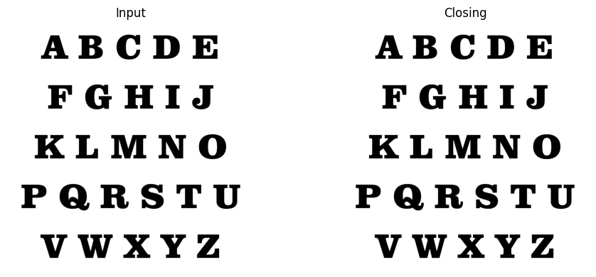
Figure 1: Closing

Closing operation is performed by first, dilating the image to fill small gaps on the object. The image is then eroded to covert it back to the original shape. This has been illustrated on figure 1 above. The input and output are difficult to differentiate hence, SSIM metric has been used. Results indicate an SSIM index of 0.8548(See figure 2 below). The proximity to 1 show that the input and output are 17% different.

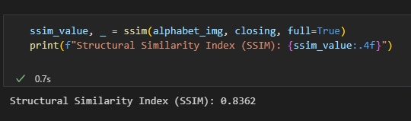

Figure 2: Closing SSIM

Opening is the inverse of the closing operation. The image is first eroded to remove noise without altering the image’s shape. Dilation is then used to restore the original shape of the image. Figure 3 below represents opening.

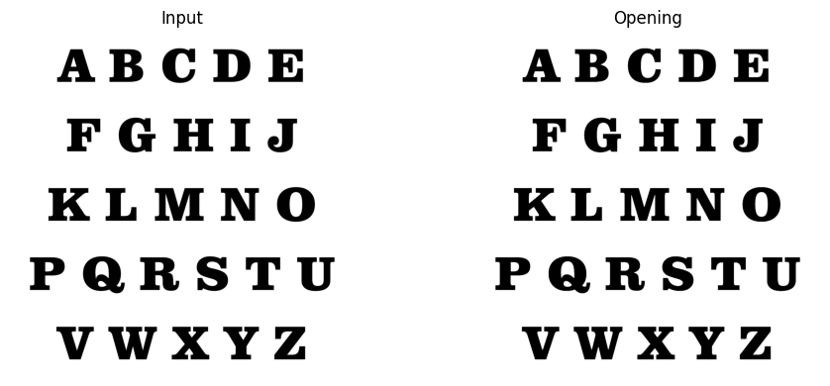

Figure 3: Opening

Similar to closing, the effect of opening is not easily discernible by the human eye. Thus, an SSIM index has been used to quantify the difference between the input and the output. The results show that the two images are 15% different.

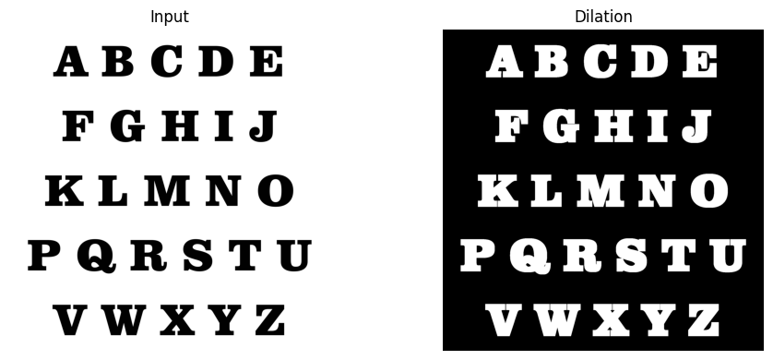
Figure 4: Dilation

Figure 4 above shows the effect of dilation on an image. To achieve this, all foreground regions have been expanded to fill gaps. As a result, the objects appear thicker than the original. Dilation is used in angiography to improve the visibility of vessels.

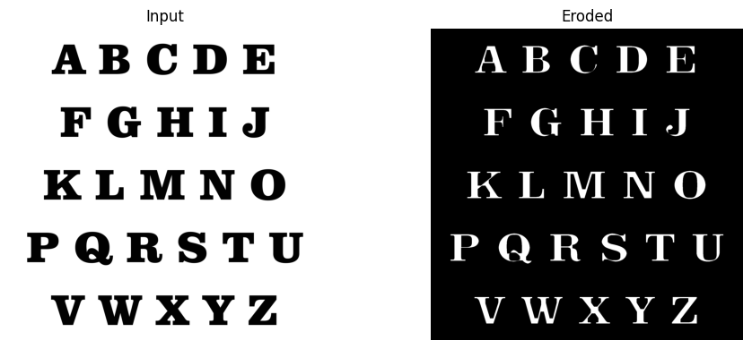

Figure 5: Erosion

Erosion morphological method is illustrated on figure 5 above. It is the opposite of dilation. The foregrand(white) regions have been eroded to remove noise resulting in thinner objects. This is normally used to separate overlapping resistors when assembling circuit boards.

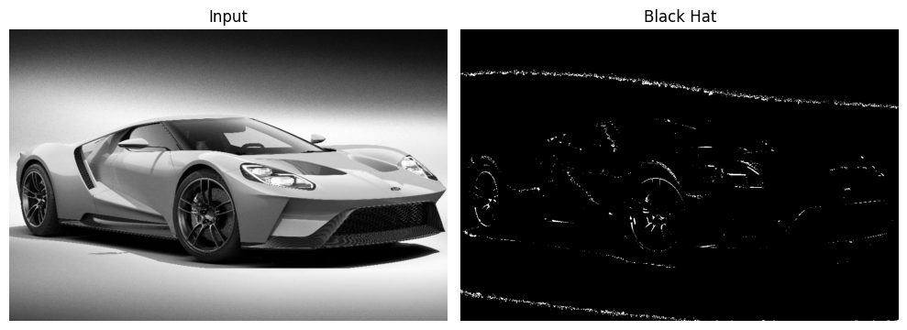

Figure 6: Black hat

Black hat transformation is shown on figure 6 above. Black hat is the difference between the original image and closing transformation. As a result the dark features on the image have been enhanced. This operation is useful for detecting unwanted materials in light environments.

Conclusion:

1. Introduction to Morphological Image Processing

Morphological image processing is a set of operations that are used to extract image elements that are useful in the description of structures of the image. These operations deal with the structure or shape of objects in the image and are primarily used to enhance, edit, or extract useful features. The fundamental goal of these techniques is to process the foreground and background of an image in such a manner that it can be easily analyzed and understood.

Morphological Image Processing Applications in the Real World: Morphological techniques are widely applied in a variety of domains since they are able to enhance image quality and aid object detection and feature extraction. In this section, we present three main areas where morphological image processing is applied:

2. Medicine Applications: Visibility of Blood Vessels

Advanced Medical Imaging: In medicine, accurate imaging is necessary for diagnosis and treatment of disorders of health. One of the greatest challenges of medical imaging is observing small or hidden details, e.g., blood vessels. Techniques like angiography are utilized for imaging blood vessels within the body, but too frequently vessels cannot be imaged because they are not detectable due to size, overlap, or obstruction.

Morphological Operations Function: Morphological image processing operations, such as dilation and erosion, are used to resolve these issues. Dilation, for instance, can be utilized to open up lighter areas in an image, thereby making the smaller blood vessels more discernible. Erosion, on the other hand, is used to close up image areas, and it acts to remove noise and unwanted artifacts.

By enhancing the appearance of blood vessels, these procedures provide doctors and clinicians improved and enhanced images, leading to more accurate diagnoses. This technique helps in the identification of blockages in arteries, aneurysms, and other vascular conditions, enabling early and accurate treatment.

3. Uses in the Construction Industry:

Identification of Structural FlawsSafety and Quality Control in Construction
In construction, it is more important to ensure that the structural stability of buildings remains intact. Even small cracks and defects in structures and walls may lead to catastrophic safety issues if not detected early and treated properly. Morphological image processing techniques are used during the inspection and monitoring of structures to detect potential hazards that the naked eye might not easily observe.
Upgrade of Structural Inspection
For instance, morphological processing like erosion can be employed to detect thin cracks or flaws on concrete surfaces. These cracks might be too thin to be readily detected by typical inspection methods, but through the use of morphological processing, they can be highlighted and accentuate areas of concern.
Dilation can be used to fill gaps or bridge discontinuities in images and help detect faults that would otherwise remain undetected. This is extremely useful in non-destructive testing where the structure is visually inspected for flaws without causing any harm.

4. Applications in Manufacturing
In manufacturing electronic parts such as circuit boards, precision is the catchword in manufacturing. Resistors, capacitors, and transistors must be placed correctly for the finished product to function. But when assembling, components are overlapped, which creates defects.

Role of Morphological Operations
Morphological operations like erosion and dilation can be applied in order to remove such overlaps by separating adjacent components. It is necessary when doing the quality control check and guarantees that all the components are in their correct location to avoid causing short circuits or other flaws that can impact the functioning of the circuit board.

For example, erosion is applied for removing small unwanted structures, while dilation is used for defining gaps among elements in a way that the detection of any assembly or position defects can be easily established.

5.Morphological Operations: Main Methods Employed Within This Research
Black Hat, Closing, Opening, Erosion, and DilationFive fundamental morphological operations are employed within this research to enhance and modify the image structure. These operations are:

- Black Hat: Dilate followed by erosion. This operation enlarges small details in the background and helps to illuminate subtle features hard to perceive.
- Closing: Dilation followed by erosion, with the aim of filling small holes or gaps within the image. This operation is usually used when processing noisy images or eliminating small deviations.
- Opening: The opposite of closing, characterized by erosion preceded by dilation. It is utilized to eliminate noise and small objects from the image, increasing the foreground's clarity.
- Erosion: Minimizes the foreground object's size by eroding pixels at the borders. Erosion can be employed for the elimination of noise at small scales or disuniting linked objects.
- Dilation: The reverse of erosion, it enlarges foreground objects in size by adding pixels to the edges. Dilation is applied to emphasize features or link neighboring objects.

These are all applied to serve different functions within image manipulation and enhancement. Erosion is particularly suitable for noise removal, whereas dilation can be better applied to select key features. Opening and closing are both light edits to the image and applied in order to refine the overall image without excessive modifications to the initial form.

6. Measuring the Effect of Morphological Operations:

SSIM Matrix Challenges in Mild Transformations
Since processes like opening and closing apply merely small transformations to the image, it is often hard to detect visually their outcomes. Small differences could not be seen right away, and hence it may prove difficult to estimate their performance unless with a numeric method.

Estimating Differences through SSIM
In order to resolve this problem, the Structural Similarity Index (SSIM) matrix is used. SSIM is a measure that quantifies the difference between two images by looking at luminance, contrast, and structural information. It is particularly effective at measuring how much two images differ from or resemble each other, which is important when estimating the effects of mild image operations such as opening and closing.

By using SSIM, we can numerically evaluate the changes in image quality and verify whether the morphological operations have actually enhanced the image in a way that benefits analysis.

7. Significance of Automatic Thresholding in Morphological Operations

Shortcomings of Manual Thresholding
Morphological operations, particularly in the case of grayscale images, require a threshold for distinguishing the foreground (features of interest) and the background (usually the irrelevant or the empty space). The threshold is crucial in distinguishing features successfully and performing operations like dilation and erosion.

However, manual thresholding is not perfect. It takes effort to manually set the threshold, and the value utilized can be best for a single image but not for another. This lack of generalizability reduces the morphological operations' stability.

Otsu's Method: A Solution for Automatic Thresholding
To counter the limitations of manual thresholding, techniques such as automatic thresholding, like Otsu's method, are employed. Otsu's method calculates the ideal threshold automatically by minimizing the intra-class variance between foreground pixels and background pixels. This renders the threshold dynamic and adaptive in accordance with the specific image being processed.

By applying automatic thresholding techniques like Otsu's method, morphological operations can be executed more accurately and reliably, which improves the overall accuracy of the image processing process.

8. Conclusion:
The Role and Importance of Morphological Operations
Improving Accuracy in Different Industries
This study demonstrates the vast applicability of morphological image processing to improve the quality and accuracy of images. From clearer visibility of blood vessels in medical imaging, fault detection in structural buildings to sanitizing electronic components in manufacturing, these processes have a crucial role in ensuring accuracy in decisions and quality outputs.

The Need for Automated Thresholding
Furthermore, this research underscores the importance of using automatic thresholding techniques in enhancing the consistency of morphological operations. With the use of techniques like Otsu's thresholding, image analysis becomes efficient, robust, and adaptive, ensuring that the desired features are clearly delineated and handled in a vast variety of image types and applications.

References:

[1] Lavrukhin, E.V. and Gerke, K.M., 2022. The Influence of Image Morphology on Neural Network-Based Segmentation Results. Advances in Systems Science & Applications, 22(4).
[2] Mi, C., Liu, Y., Zhang, Y., Wang, J., Feng, Y. and Zhang, Z., 2023. A vision-based displacement measurement system for foundation pit. IEEE transactions on instrumentation and measurement, 72, pp.1-15.
[3] Pyt’ev, Y.P., Chulichkov, A.I., Falomkina, O.V., Balakin, D.A. and Zubyuk, A.V., 2025. Morphological Image Analysis: Mathematical Foundations and Applications. In Image Analysis and Pattern Recognition: State of the Art in the Russian Federation (pp. 81-118).
[4] Tian, F., Gao, Y., Fang, Z. and Gu, J., 2021. Automatic coronary artery segmentation algorithm based on deep learning and digital image processing. Applied Intelligence, 51(12), pp.8881-8895.
[5] Tomasila, G., 2022. Sand Soil Image Processing Using the Watershed Transform and Otsu Thresholding Based on Gaussian Noise. JINAV: Journal of Information and Visualization, 3(1), pp.81-92.
[6] Wang, H., Qiu, X., Zeng, F., Shao, W., Ma, Q. and Li, M., 2022. Detection of physical descaling damage in carp based on hyperspectral images and dimension reduction of principal component analysis combined with pixel values. Journal of Food Science, 87(6), pp.2663-2677.
[7] Zhang, B., 2021. Reconfigurable morphological processor for grayscale image processing. Electronics, 10(19), p.2429.

